**Debiasing Word embeddings**

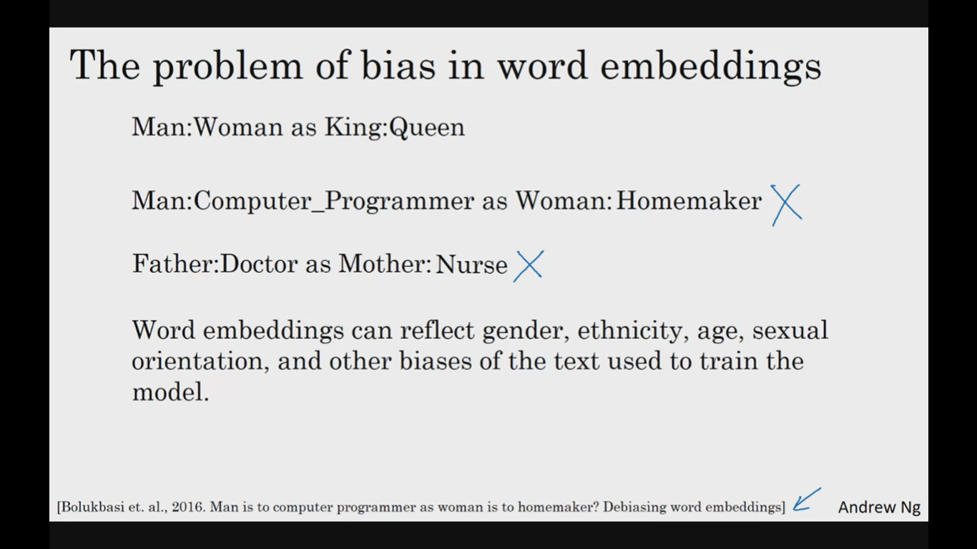

need to neutralize which is not biased like gender specific such as baby sitter doctor etc

